LAB ASSIGNMENT-1



NAME: M Gyanada Chowdary

REG.NO: 21bce7727

COURSE: Computer Networks

SLOT: L21+22

TASK: CREATE A WAN NETWORK WITH 3 ROUTERS WITH STATIC ROUTING.

To create a WAN with 3 routers

Step 1: Create two LAN’s using 2960 switch and PC’s as end devices.

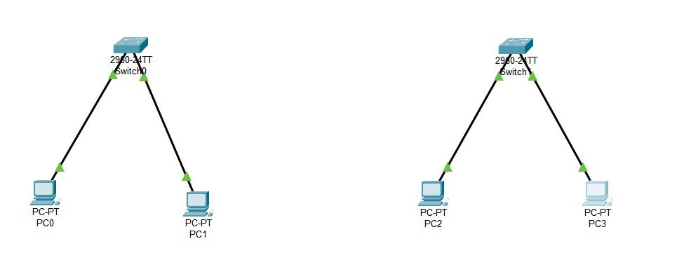

Step 2: connect each LAN to a router.

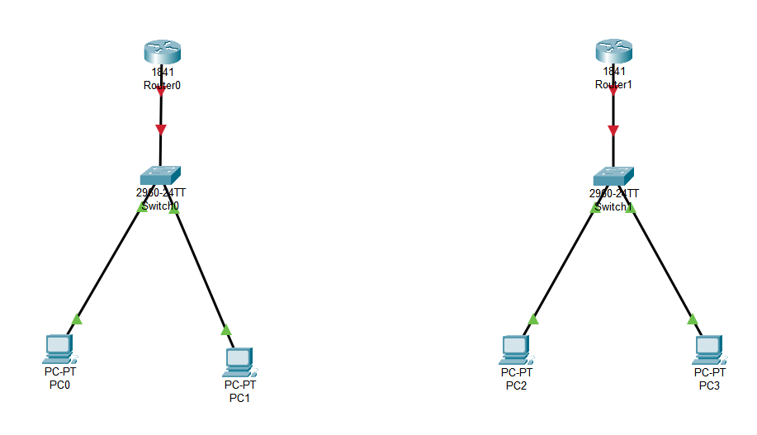

Step 3: Connect these routers to another router.

Before That Switch off the routers and add HWIC-2T which creates serial ports

And using serial DCE connect the three routers.

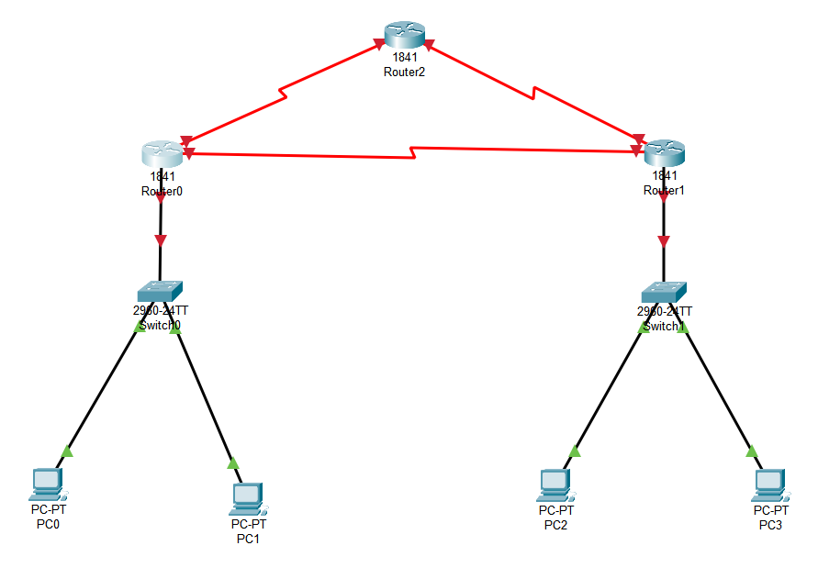

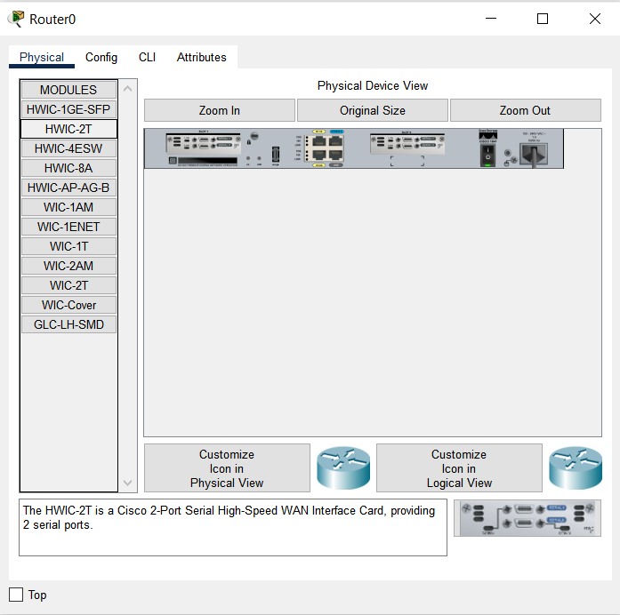

Step 4:

Using CLI configure the routers.

For Router 0

FastEthernet0/0 - 10.0.0.3

Serial0/1/0 - 40.0.0.1

Serial0/0/0 – 30.0.0.1

For Router 1

FastEthernet0/0 -20.0.0.3

Serial0/0/0 – 30.0.0.2

Serial0/1/0-50.0.0.2

For Router 2

Serial0/1/0 - 40.0.0.2

Serial0/0/0 - 50.0.0.1

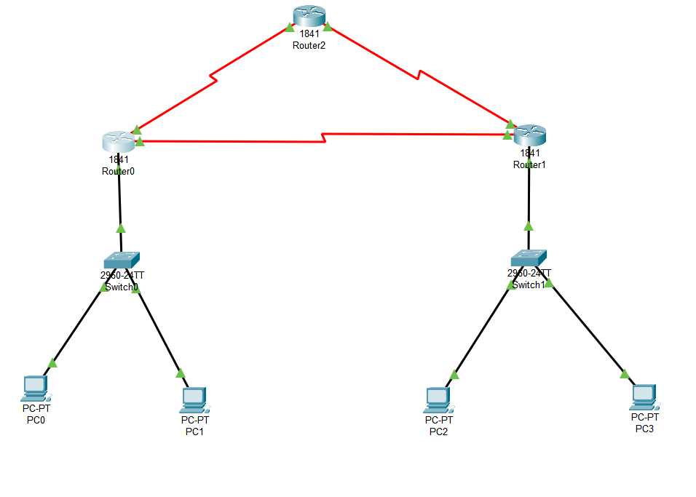

Step 5: Static Routing

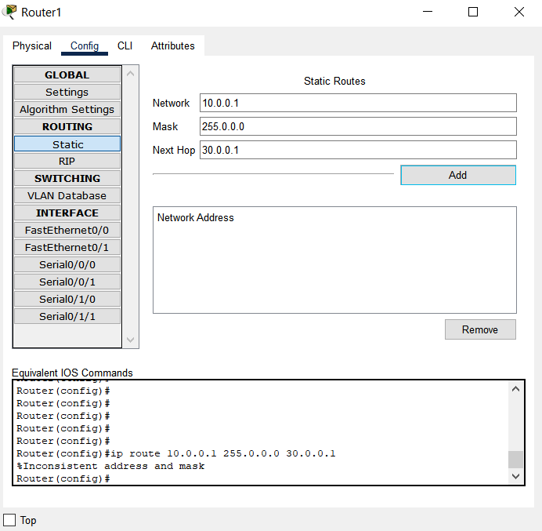

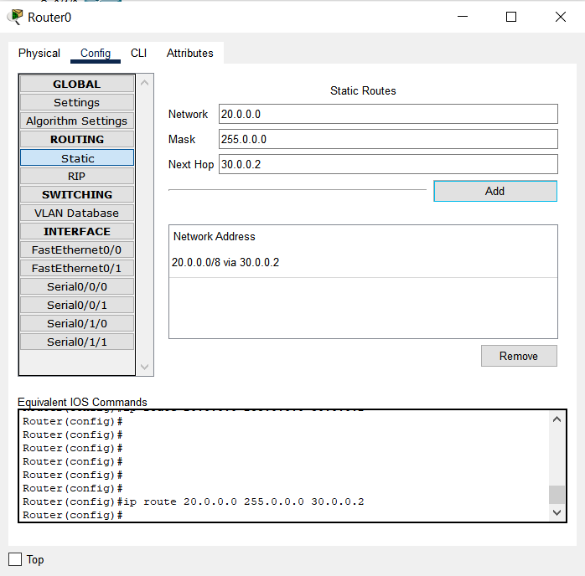

Step 6: Take a Simple PDU and check if network is working.

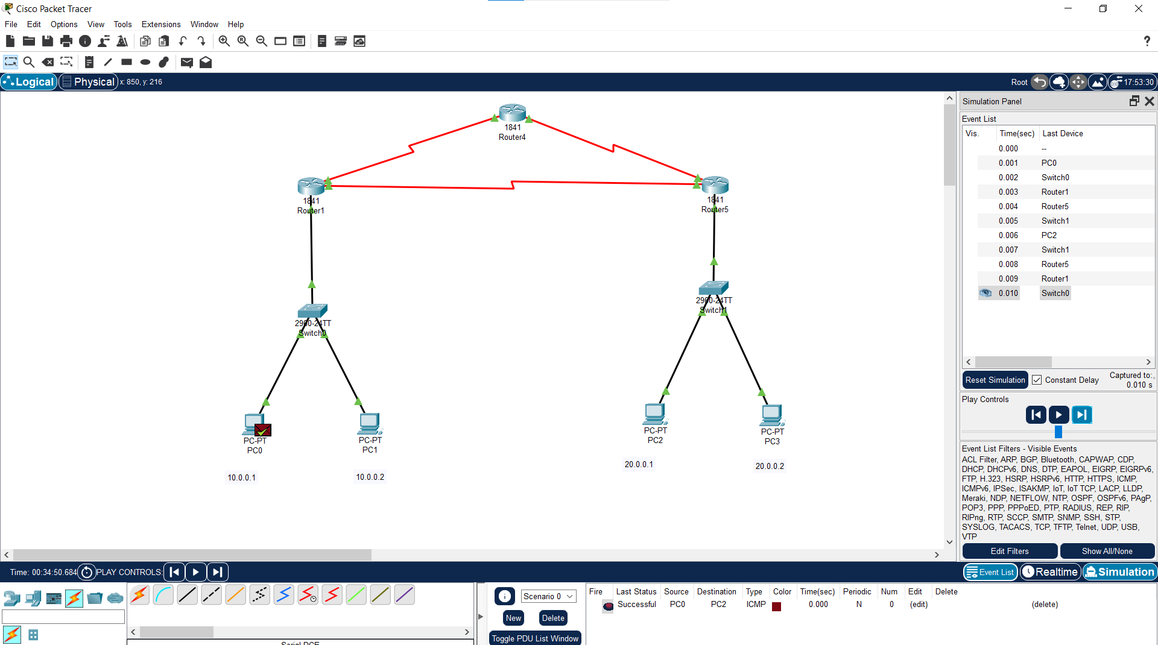

Simulation Successful.